**CNSL Lab Assignment 12**

**Neeti Kurulkar**

**To study SSL protocol by capturing the packets using Wireshark tool while visiting any SSLsecured website (banking, e-commerce, etc)**

1. **An SSL Protected Website**

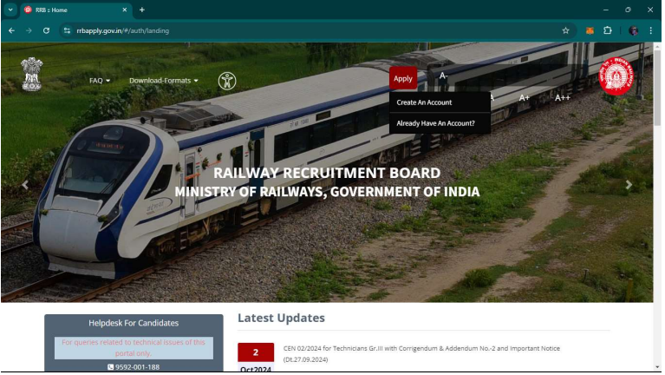

1. **Filtering SSL and TCP Stream 6**

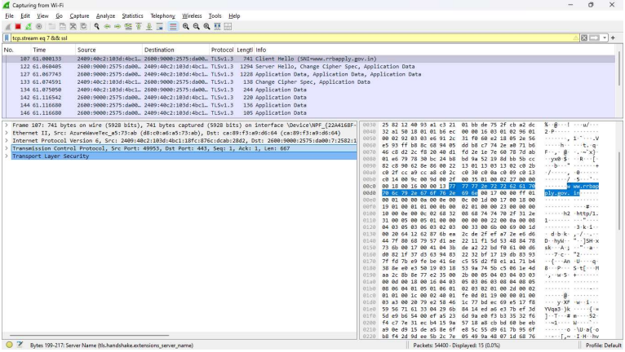

1. **TLS Handshake Protocol for Client Hello**

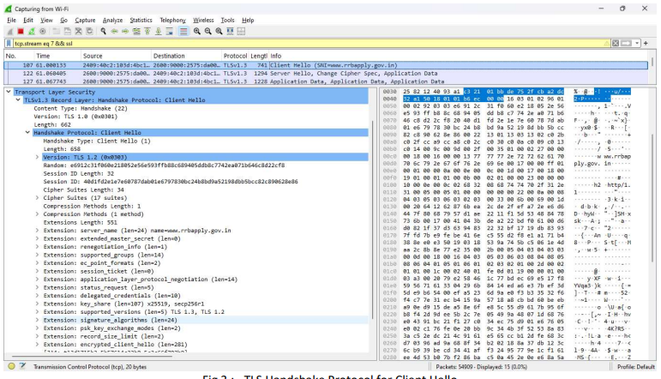

1. **TLS Handshake Protocol for Server Hello**

